SAE Name: _______________________________

Sekundarschulabschluss für Erwachsene Nummer: __________

Englisch A 2021

- Totalzeit: 90 Minuten
- Hilfsmittel: Wörterbuch in Buchform Muttersprache – Englisch für Teil D, Schreiben
- Maximal erreichbare Punktzahl: 100
- Für die Maximalnote 6 erforderliche Punktzahl: 95
- Für die Note 4 erforderliche Minimalpunktzahl: 55

Übersicht über die SAE Sek-A Englischprüfung

A | Hörverständnis | 2 Hörtexte | 30 Punkte
B | Leseverständnis | 2 Lesetexte | 30 Punkte
C | Grammatik und Wortschatz | 3 Aufgaben | 20 Punkte
D | Schreiben | 1 Aufgabe | 20 Punkte

Rechtschreibefehler bei Teil A und B haben keinen Punkteabzug zur Folge.

A Listening comprehension (30 points)

Lesen Sie die Fragen sorgfältig durch bevor Sie den Text hören.

Sie hören jeden Teil zweimal.

Part 1 You are going to listen to somebody talking about “A Polar Bear Hotel”.
Länge des Hörtextes: 2:55 mins ___ / 12P
A Füllen Sie die Lücken in den Sätzen 1 – 6 aus.
- The Polar Bear Hotel is ……………………………………………. the Harbin Polarland
amusement park.
- Polar bears keep you company whenever you’re eating, playing ..……………………….
- The bears are let outdoors when temperature and ……………………………….. permit.
- Animal rights activists have ……………..………………………………………… the hotel.
- Polar Bears wandering home ranges that can span …………………….…………………
- Harbin Polarland calls itself the world’s first polar ……………………………….…………
amusement park.

B Beim zweiten Hören beantworten Sie die folgenden Fragen, indem Sie das richtige
Kästchen ankreuzen.
___ / 3P
7. People watching polar bears in …………...
a closed, outdoor space area.
a large icy area.
small pools of water.
a natural surrounding.

8. Polar bears are active for …….
at least 18 hours a day.
up to 18 hours a day.
18 hours a day.
8 hours a day.

9. Videos showed a polar bear ……… Pizza.
eating
named
playing with a
searching for a
Part 2 HBO’s “Game of Thrones” breaks Emmy Record.

Länge des Hörtextes: 4:06 mins

A Füllen Sie die Lücken in den folgenden Sätzen.
___ / 12P
10. The Television Academy honoured the show’s ….………….………… and final season.
11. A police show, NYPD Blue had held ………………………………………….. since 1994.
12. If Game of Thrones defends the best drama series prize, it will ……………………….....
four of the most honoured dramas.
13. Ratings …..……………………………………………………….……………. for the series.
14. Sandra Oh became the first ……….…………………………… actress to win an Emmy.
15. It is possible to watch the Emmy Awards ceremony live on .……………………………. .

B Beim zweiten Hören beantworten Sie die folgenden Fragen, indem Sie das
richtige Kästchen ankreuzen.
___ / 3P
16. In one of the broadcast of one episode am mayor mistake appeared.
Rap
House
a modern day paper coffee cup
Rock

17. Who is the Emmy record holder?
Emilia Clarke
Sandra Oh
Rachel Brosnahan
Julia Louis Dreyfus

18. Saturday Night Live is ……
a comedy skit show.
a nuclear disaster.
a fantasy.
a drama.
B Reading comprehension (30 points)

Part 1
Lesen Sie den Text sorgfältig durch. Beantworten Sie dann die folgenden Fragen.

What's the difference between Great Britain and the United Kingdom? What's the best English music festival? And do English people really drink a lot of tea? Read about England and find out!

England is the biggest of the four countries in the United Kingdom. Together with Scotland and Wales, these three countries are the island of Great Britain. The English Channel is in the south between England and France. People travel to France by ferry across the English Channel or by train through the Channel Tunnel which goes under the sea.
Over 50 million people live in England and that’s around 80 per cent of the total UK population. It is a multicultural country where more than 250 languages are spoken in the capital city, London. The United Kingdom is a constitutional monarchy, which means that there is a queen or king but they don’t make the laws of the country. Laws and political decisions in England are made by the Parliament of the United Kingdom. The Houses of Parliament are in central London next to the River Thames and the most famous part is the clock tower, Big Ben.
Other large cities in England are Birmingham, Manchester, Liverpool, Leeds and Bristol. Outside cities, England is a very green country and has many rural areas of natural beauty such as the Lake District, an area with lots of lakes in the north, and the New Forest, a big area of forest in the south of the country.

Language
The official language of England is English, which is spoken today by millions of people all over the world. Many students go to England from other countries to study the language and learn about the culture. Although everyone speaks English, there are many different accents around the country. French was the official language in England between 1066 and 1362, which is why there are many French words and expressions in English such as ‘bon voyage’ for ‘have a good trip’ or ‘bouquet’ for ‘a bunch of flowers’.

Music
English people love music. In the summer you can go to music festivals all over the country like those at Glastonbury, Leeds or Reading. Glastonbury is a five-day festival of music, dance, comedy, theatre and circus and around 175,000 people go. Many people stay at the festivals for a few days and camp in tents. People listen to all types of music, especially pop and rock. England has produced many international groups and singers like the Beatles, Amy Winehouse, Coldplay, Ed Sheeran and Adele.

Sport
The most popular sports in England are football, rugby and cricket and most towns have a sports ground where teams can play. English football teams like Manchester United, Chelsea and Liverpool are world-famous and English football players include David Beckham, Wayne Rooney and Harry Kane. Women’s football is also popular and teams play in leagues and competitions all over the country. Every year, the English rugby union team play in the Six Nations Championship against Wales, Scotland, Ireland, France and Italy. Cricket is a traditional sport played with a bat and ball which began in England and is now played all over the world. People like to watch all these sports on television, as well as other sports like horse racing, tennis, snooker (a type of billiards) and motor racing.

Food
England is a very multicultural country and this has a big influence on the food people eat. Indian, Chinese and Italian cuisines are popular alternatives to traditional English food like fish and chips, roast beef or sausage and mash (mashed potatoes). Many English people drink several cups of tea every day, usually with milk. However, coffee and herbal teas are also popular.

Symbols
The national flag of England is white with a red cross. It is called the St George’s Cross and Saint George is the patron saint of England. St George’s Day is on 23 April, but it’s not a public holiday. The rose is the national flower of England and the lion is the national animal. The lion is a symbol of many English sports teams.

Text out of: britishcouncil.org/learnenglishteens

Beantworten Sie die folgenden Fragen indem, Sie die richtige Antwort ankreuzen.

___ / 5P

a) Which of the following statement is true?
There is a queen and a king in the United Kingdom.
Big Ben isn’t part of the Houses of Parliament.
People in England don’t like coffee.
Cricket is a very popular ball game in England.

b) More than 250 languages are spoken …….
in Scotland
in Northern Ireland
in London
in Manchester

c) “Six Nations” is ………
a rugby competition
another name for the United Kingdom
a football competition
a music festival

d) “mash” is …….
short for Manchester
a comedy show
traditional food
a music group

e) Which of the following statement is true?
People only travel from England to France by ferry.
The laws of England are made by the Queen.
The lion is a symbol of many English sports teams.
The New Forrest is a big area in the north of England.

Beantworten Sie die folgenden Fragen so genau wie möglich.
___ / 10P

Please answer in English.

f) Which countries build Great Britain? …………………………………………………………………………………..………………………..
…………………………………………………………………………………..………………………..

g) English wasn’t always the official language in England.
Which other language(s) was / were official language(s)?
…………………………………………………………………………………..………………………..
……………………………………………………………………………………………………….……

h) Which kind of music is mostly played at Glastonbury festival?
…………………………………………………………………………………..………………………..
……………………………………………………………………………………………………….……

i) Why are so many French expressions part of the English language?
…………………………………………………………………………………..………………………..
……………………………………………………………………………………………………….……
……………………………………………………………………………………………………….……
……………………………………………………………………………………………………….……

k) What does the Lion in England symbolise?
…………………………………………………………………………………..………………………..
……………………………………………………………………………………………………….……
……………………………………………………………………………………………………….……

Part 2
Lesen Sie den Text sorgfältig durch. Beantworten Sie dann die folgenden Fragen.

Some of the richest Rock Stars in the World.
A
Many young musicians dream of being a rock star for the fame and adoration, even though it's a grueling lifestyle of non-stop touring.
These starving artist types have a big surprise coming if they break into the big time, because you can make an unbelievable amount of money as one of the richest rock stars in the world.
As you read this list, you'll find out three major takeaways as an upcoming rocker:
- Anyone (though it helps to have connections) can breakthrough and become incredibly
wealthy as a rock star.
- But if you want to be among the richest with the highest net worths, you'll need to venture into other businesses, make savy investments, get into TV and film, and control your
expenses.
- And that's partially because you'll be splitting your music money 4 and 5 ways with band
members.
Gaining the marketing momentum and exposure is a lifelong process that requires the help of a big record label. And in this genre you do have to actually be able to write songs and play an instrument, unlike others. If you know the right people and make the right moves, you can become one of the richest rock stars in the world.

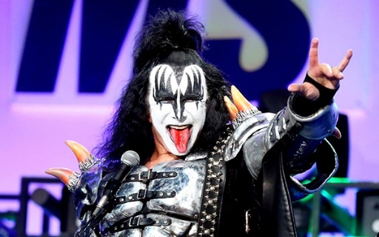
B
Gene Simmons: NET WORTH: $350 MILLION
You know Gene as The Demon, the bassist and co-lead singer of KISS. Gene is credited for their successful merchandising franchise, including action figures, lighters, pinball games, and much more. They actually dropped the makeup and costumes for a decade or so and experienced a huge resurgence in popularity (that they of course brought back later).
His other businesses include his own record label, Simmons Records, his own magazine, an animated series, a few reality TV shows, a film production company, and a failed AFL football team. That doesn't mean he didn't make a profit, though.
Trivia Fact: Gene's real name is Eugene Klein and his birth name is Chaim Witz. The stage name Gene Simmons is a tribute to the rockabilly singer Jumpin' Gene Simmons. He credits The Beatles as the template for knowing how to be a rock star. He blames file sharing for the decline of the music industry and the death of rock and roll in particular.

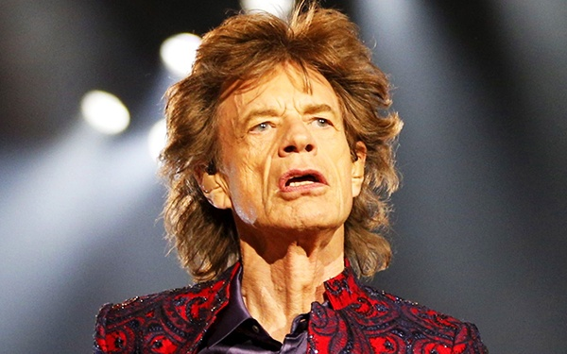
C
Mick Jagger: NET WORTH: $360 MILLION
Sir Michael Jagger hit it huge as the lead singer for The Rolling Stones. In his solo career and with the Stones, he's had 13 #1 singles and 32 within the top 10. He's got all the awards and honors, including knighthood. He's been performing in front of gigantic crowds since the 1960's and still does to this day.
How he had time to create an illustrious acting career is beyond me. As far as extra businesses go, he's only created Jagged Internetworks that covers the cricket sport. Otherwise he's a supporter of music education in schools. Such a legend need not have extra ventures like mere mortals.
Trivia Fact: Mick Jagger and Keith Richards went to grade school together. It's hard to say if his lifelong feuding with bandmate Richards has helped their success or hindered it. He's produced 8 children from 5 women! A 19 million year old Jaggermeryx naida and a trilobite species Aegrotocatellus jaggeri were both named after him.

D
Elton John: NET WORTH: $450 MILLION
Sir Elton John has sold more than 300 million albums to date. He holds the best selling single of all time in the USA and UK. All these albums, touring, awards, and merchandising built his financial base, but his compositions for The Lion King movie and the recent Rocketman biopic about his life only catapulted him further.
Elton would be much higher up this list if not for his crazy spending habits, such as spending $40 million in the year 2000. He was buying more cars than he literally had a chance to drive! His residencies at Caesar's Palace in Las Vegas have totaled 11 years and undoubtedly earned him a huge chunk of his net worth.
Trivia Fact: Elton does great work with his Elton John AIDS Foundation. He's also been an early and constant speaker for human rights globally. His voice was previously classed as a tenor but now falls in the range of baritone.

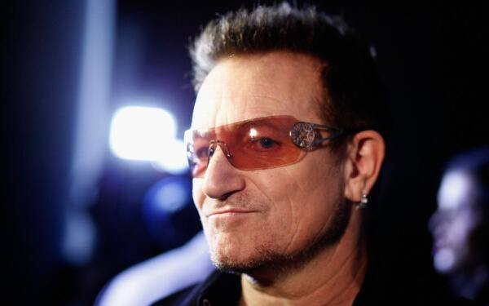
E
Bono: NET WORTH: $700 MILLION
As the lead singer of U2, he knocks down some serious cheddar. But his extra-curricular activities as a venture capitalist, philanthropist, and businessman in general have launched him to incredible heights. He's been knighted and is addressed as "Paul David Hewson, KBE OL."
Like The Beatles, U2 is so successful that his other bandmates are almost on this list. Their marketing is top notch as well. Who doesn't know of Bono as the guy that wears the sunglasses and cares about ecological issues? You don't become a household name by accident.
Trivia Fact: Many were surprised when Bono's name appeared in the Paradise Papers, which provided proof that countless members of the 1% were engaging in complicated schemes that amount to tax evasion. So much for being a huge social activist...

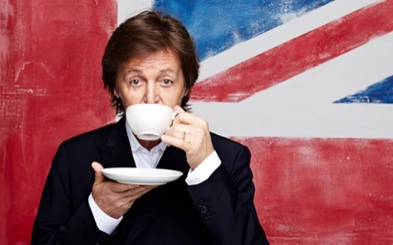
F
Paul McCartney: NET WORTH: $1.2 BILLION
Of course, the surviving member of the Lennon-McCartney duo is the reigning king. Even splitting the money four ways hasn't stopped two of the members of The Beatles from reaching the top 10. Add on Paul's lengthy solo career, his time with the band Wings, and his collaborations with other stars like Michael Jackson and Kanye West... he's been a pop icon since the 1960's.
He's either written or co-written 32 songs that hit #1 on the Billboard Hot 100. Think about the royalties he receives from the fact that his song Yesterday is the most covered song of all time (over 2,200 other artists have created their own versions).
Trivia Fact: It is said that McCartney holds over 25,000 copyrights. He's been knighted (that's Sir Paul to you!) and holds the Guinness Book of World Records places for the most honored composer and the most successful songwriter of all time.

Text out of : https://ledgernote.com/blog/interesting/top-10-richest-rock-stars-in-the-world
Schreiben Sie den Buchstaben des Absatzes in die Tabelle so ein, wie es im Beispiel vorgegeben ist. (Es sind alle Absätze A – F möglich)
___ / 5P

 | Statement | Paragraph
Example | In this paragraph you get to know why being a rock star is a grueling lifestyle. | A
a | This paragraph gives you a reason for the decline of the music industry.
b | This paragraph gives you some advice how to become one of the richest rock stars.
c | This paragraph tells you how somebody was wasting money.
d | This paragraph tells you since when somebody is an idol.
e | This paragraph tells you about somebodies illegal actions.

Beantworten Sie die folgenden Fragen so genau wie möglich. ___ / 10P

Please answer in English.

f) Which of the rock stars is been famous and successful on his own all the time?
……………………………………………………………………………………………………….……

g) From which rock star do we get to know where he lives?

……………………………………………………………………………………………………….……
……………………………………………………………………………………………………….……

h) Gene Simmons is the only one of the list who is not ………….. ?
……………………………………………………………………………………………………….……
……………………………………………………………………………………………………….……

i) What is needed to become one of the richest rock stars in the world? (3 reasons)

……………………………………………………………………………………………………….……
……………………………………………………………………………………………………….……

k) Which of the rock stars performed together with the most of different other artists or bands?
Name the rock star and the other artists or bands.
……………………………………………………………………………………………………….……
……………………………………………………………………………………………………….……
……………………………………………………………………………………………………….……
C Use of English (20 points)

Part 1: ___ / 7P
Falls der unterstrichene Satzteil richtig ist, machen Sie ein Häkchen, , korrigieren Sie falsche Satzteile und schreiben die richtige Lösung auf die Zeile neben dem Satz.

1. How many sugar do you take in your coffee? ………………………………...………………….
2. I’ll have to post some of my luggage. ………....…………………………………………………..
3. I felt extrem nervous before the exam. ……………..…………………………….….…………..
4. I can’t put up with all this noise. ……………………………………………………………………
5. I will buy a new car if I had enough money. .…………….……………………………………….
6. He is too young for driving. ………………….………..............................................................
7. I’m going to finish this work before I will go. ………………………….…………………………..

Part 2: ___ / 6P
Vervollständigen Sie die folgenden Sätze. Kreuzen Sie die richtige Box an.

- That student over there – the one ................. .
in the blonde hair with the blonde hair
in blonde hair blonde haired

- When ………. a job, I’ll look for a place.
I find I’m going to find I’ve found I had found

- They’ll start playing as soon as it ………. raining.
stops will stop is going to stop has stopped

- We’ll sit outside until it …………….. dark.
gets is going to get dark will get is getting

- After she …………. the course, she’ll be a qualified teacher.
will take is taking has taken had taken

- When the programm ……………, I’ll do the washing up.
is ending is going to end ends has ended
Part 3: ___ / 7P
Wählen Sie das richtige Wort aus um die Sätze zu vervollständigen und kreuzen
Sie es an.

1. We were all set to go down to the beach. Then, for no ……… reason, Mike said he
wanted to stay in.
particular certain detailed topical

2. Have you got the ............... edition of the product catalogue? This one seems to be last
years.
modern late current present

3. There’s no ……… trying to get everything done today – we’ll only make a mess of things if
we rush the job.
cause logic point sense

4. The taxi drivers in my city are ........... drivers.
danger dangerous dangerously dangers

5. Can you .................. me your pen, please.
borrow loan lend supply

6. Although this month’s sales have shown an improvement on last month’s, ………. things
aren’t looking too bright.
in the long run in the long term
in the long course in the long session

7. LED bulbs are a really ………… way of lighting a room because they last so long.
economic economical
economicaly economicly

D Writing (20 points)

Sie müssen nur Part 1 oder Part 2 bearbeiten.

Part 1: “One of my happiest moments in my life” ___ / 20P

- Tell what and why it was your happiest moment.

Textlänge: 80 – 100 Wörter

Beurteilungskriterien: Inhalt / Aufgabenerfüllung (8 Punkte), Textmerkmale / Textqualität
(4 Punkte), Wortschatz (4 Punkte), grammatische Strukturen (4 Punkte).

ODER

Part 2: “A movie / series everybody should have seen” ___ / 20P
- Name / title of the movie / series
- describe what the movie / series is all about
- Why should everybody have seen it?

Textlänge: 80 – 100 Wörter

Beurteilungskriterien: Inhalt / Aufgabenerfüllung (8 Punkte), Textmerkmale / Textqualität
(4 Punkte), Wortschatz (4 Punkte), grammatische Strukturen (4 Punkte).

Part ___: Title: ____________________________________________________________

…………………………………………………………………………………………………………..
…………………………………………………………………………………………………………..
…………………………………………………………………………………………………………..
…………………………………………………………………………………………………………..
…………………………………………………………………………………………………………..
…………………………………………………………………………………………………………..
…………………………………………………………………………………………………………..
…………………………………………………………………………………………………………..
…………………………………………………………………………………………………………..
…………………………………………………………………………………………………………..
…………………………………………………………………………………………………………..
…………………………………………………………………………………………………………..
…………………………………………………………………………………………………………..
…………………………………………………………………………………………………………..
…………………………………………………………………………………………………………..
…………………………………………………………………………………………………………..
…………………………………………………………………………………………………………..
…………………………………………………………………………………………………………..
…………………………………………………………………………………………………………..
…………………………………………………………………………………………………………..
…………………………………………………………………………………………………………..
…………………………………………………………………………………………………………..
…………………………………………………………………………………………………………..
…………………………………………………………………………………………………………..
…………………………………………………………………………………………………………..
…………………………………………………………………………………………………………..
…………………………………………………………………………………………………………..
…………………………………………………………………………………………………………..
…………………………………………………………………………………………………………..
…………………………………………………………………………………………………………..
…………………………………………………………………………………………………………..
…………………………………………………………………………………………………………..
…………………………………………………………………………………………………………..
…………………………………………………………………………………………………………..
…………………………………………………………………………………………………………..
…………………………………………………………………………………………………………..
…………………………………………………………………………………………………………..
…………………………………………………………………………………………………………..
…………………………………………………………………………………………………………..
…………………………………………………………………………………………………………..
…………………………………………………………………………………………………………..
…………………………………………………………………………………………………………..
…………………………………………………………………………………………………………..
…………………………………………………………………………………………………………..
…………………………………………………………………………………………………………..
…………………………………………………………………………………………………………..
…………………………………………………………………………………………………………..
…………………………………………………………………………………………………………..
…………………………………………………………………………………………………………..
…………………………………………………………………………………………………………..

